Ek – Fasıl 29
Sayfa | Başlık | Paragraf |  |  | Tanımlama | Kimyassal Yapı
 | General | (G) |  |  | Classification of esters, salts, co-ordination compounds and certain halides
 |  |  | (1) |  | Esters
VI-29-7 |  |  |  | (a) |  | 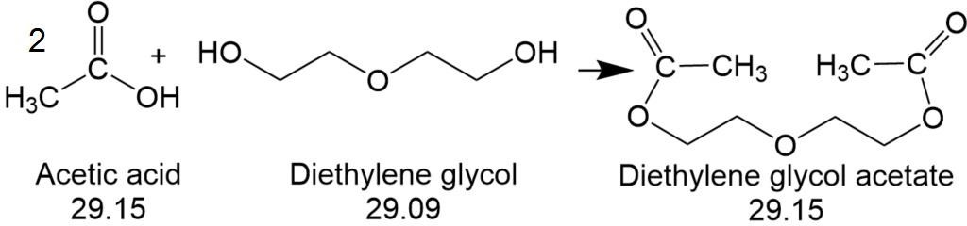
 |  |  |  | (b) |  | 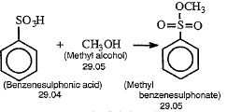
 |  |  |  | (c) |  | 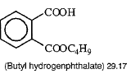
Fasıl 29 AÇIKLAMA NOTLARINDA TANIMLANAN BAZI ÜRÜNLERİN KİMYASAL YAPISI

Ek – Fasıl 29

Sayfa | Başlık | Paragraf |  |  | Tanımlama | Kimyasal Yapı
(VI-29-7) |  | (G) | (1) | (d) |  | 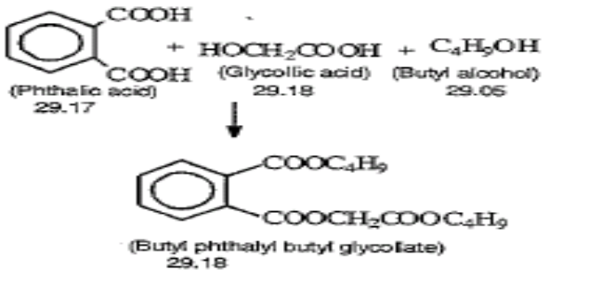
 |  |  |  | (d) |  | 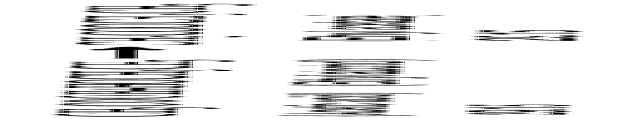
 |  |  | (2) |  | Salts
 |  |  |  | (a) (i) |  | 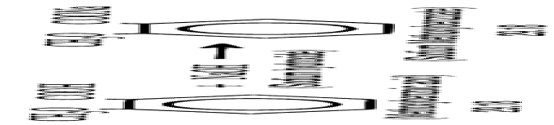
Ek – Fasıl 29
Sayfa | Başlık | Paragraf |  |  | Tanımlama | Kimyasal Yapı
(VI-29-7) |  | (G) | (2) | (a) (i) |  | 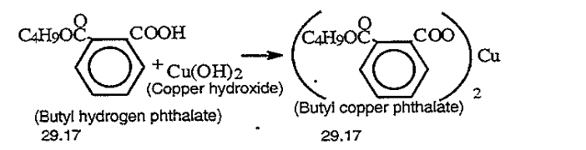
 |  |  |  | (ii) |  | 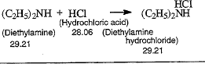
VI-29-8 |  |  |  | (b) (i) |  | 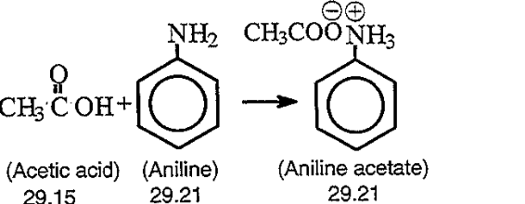
 |  |  |  | (ii) |  | 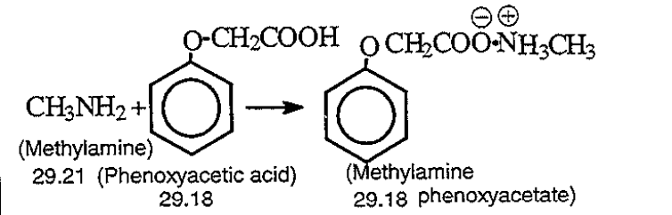

Ek – Fasıl 29

Sayfa | Başlık | Paragraf |  |  | Tanımlama | Kimyasal Yapı
VI-29-9 |  | (G) | (4) |  | Halides of carboxylic acids (Isobutyryl chloride: 29.15) | 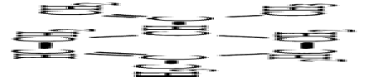  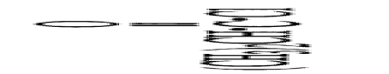
 | 29.02 |  |  |  | Cyclic hydrocarbons
 |  | (B) |  |  | CYCLOTERPENES
VI-2902-2 |  |  | (3) |  | Limonene
 |  | (C) |  |  | AROMATIC HYDROCARBONS
VI-2902-3 |  |  | (I) | ( c) | o-xylene | 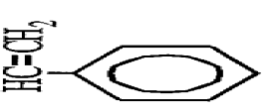  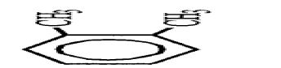
 |  |  |  | (d) (1) | Styrene
 | 29.03 |  |  |  | Halogenated derivatives of hydrocarbons
 |  | (F) |  |  | HALOGANATED DERIVATIVES OF AROMATIC HYDROCARBONS

Ek – Fasıl 29

Sayfa | Başlık | Paragraf |  |  | Tanımlama | Kimyasal Yapı
VI-2903-4 | (29.03) | (F) | (6) |  | DDT(ISO) (clofenotane (INN), 1,1,1-trichloro-2,2- bis (p-chlorophenyl) ethane or discholorodiphenyltrichloroethane) | 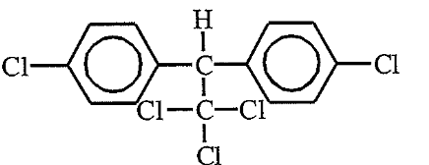
 |  | F | (11) |  | 2.2'.4.4'.5.5'-  hekzabromobifenil | 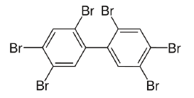
 | 29.04 |  |  |  | Sulphonated, nitrated or nitrosated derivatives of hydrocarbons, whether or not halogenated
 |  | (A) |  |  | SULPHONATED DERIVATIVES
VI-2904-1 |  |  | (1) | (a) | Ethylenesulphonic acid | 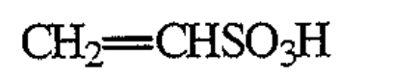
 |  | (B) |  |  | NITRATED DERIVATIVES
 |  |  | (1) | (d) | Trinitromethane | 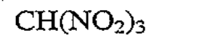
 |  | ( C ) |  |  | NITROSATED DERIVATIVES
VI-2904-2 |  |  | (2) |  | Nitrosotoluene | 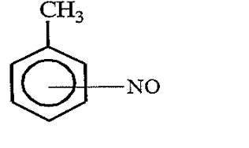
Ek – Fasıl 29

Sayfa | Başlık | Paragraf |  |  | Tanımlama | 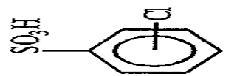  Kimyasal Yapı
(VI-2904-2) | (29.04) | (D) |  |  | SULPHOHALOGENATED DERIVATIVES
 |  |  | (1) |  | Chlorobenzenesulphonic acid
 |  |  | (5) |  | Perfluorooktan sülfonik asit (PFOS) | 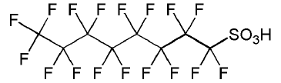
 | 29.05 |  |  |  | Acyclic alcohols and their halogenated, sulphonated, nitrated or nitrosated derivatives | 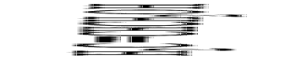
 |  | (B) |  |  | UNSATURATED MONOHYDRIC ALCOHOLS
VI-2905-3 |  |  | (1) |  | Allyl alcohol
 |  | ( C ) |  |  | DIOLS AND OTHER POLYHYDRIC ALCOHOLS
 |  |  | (II) | (4) | Mannitol | 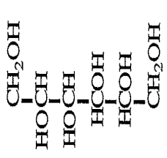

Ek – Fasıl 29

Sayfa | Başlık | Paragraf |  |  | Tanımlama | Kimyasal Yapı
 | 29.06 |  |  |  | Cyclic alcohols and their haloganated, sulphonated, nitrated or nitrosated derivatives
 |  | (A) |  |  | CYCLANIC, CYCLENIC OR CYCLOTERPENIC ALCOHOLS AND THEIR HALOGENATED, SULPHONATED, NITRATED OR NITROSATED DERIVATIVES
VI-2906-1 |  |  | (1) |  | Menthol | 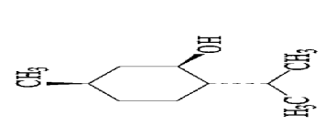
 | 29.07 |  |  |  | Phenols; phenol-alcohols
 |  | (A) |  |  | MONONUCLEAR MONOPHENOLS
VI-2907-2 |  |  | (2) |  | Cresol(s) | 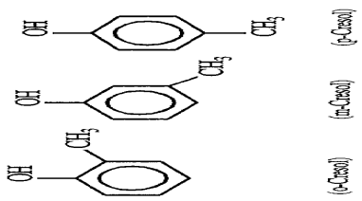

Ek – Fasıl 29

Sayfa | Başlık | Paragraf |  |  | Tanımlama | Kimyasal Yapı
(VI-2907-2) | (29.07) | (B) |  |  | POLYNUCLEAR MONOPHENOLS
 |  |  | (1) |  | Naphtol(s) | 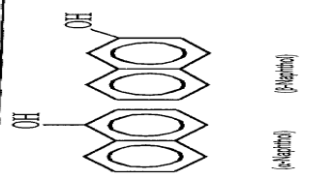
 |  | ( C) |  |  | POLYPHENOLS
 |  |  | (1) |  | Resorcinol | 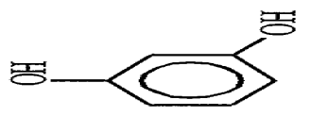
VI-2907-3 |  |  | (3) |  | Bisphenol A | 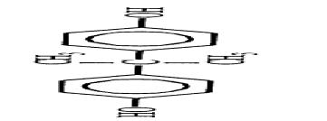
Ek – Fasıl 29

Sayfa | Başlık | Paragraf |  |  | Tanımlama | Kimyasal Yapı
 | 29.09 |  |  |  | Ethers, ether-alcohols, ether-phenols, ether-alcohol-phenols, alchols peroxides, ether peroxides, ketone peroxides (whether or not chemicallydefined), and their halogenated, sulphonated, nitrated or nitrosated derivatives
 |  | ( C ) |  |  | ETHER-PHENOLS AND ETHER-ALCOHOL-PHENOLS
VI-2909-3 |  |  | (1) |  | Guaiacol | 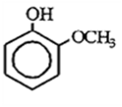
 |  | (D ) |  |  | ALCOHOL PEROXIDES,ETHER PEROXIDES AND KETONE PEROXIDES
VI-2909-4 |  |  |  |  | Ketone peroxides (Cyclohexanone peroxide) | 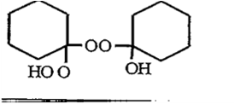
 |  |  |  |  | 1,1-di(tert-butylperoxy)cyclohexane | 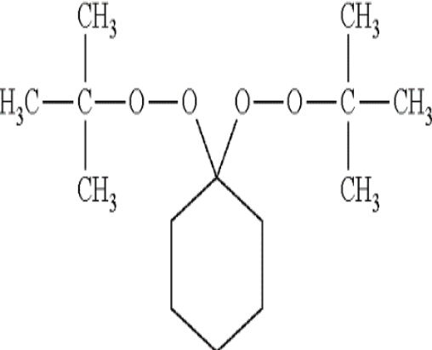
 | 29.10 |  |  |  | Epoxides,epoxyalcohols,epoxyphenols and epoxyethers,with a three membered ring, and their haloganated,sulphonated,nitrated or nitrosated derivatives
VI-2910-1 |  | (1) |  |  | Oxirane | 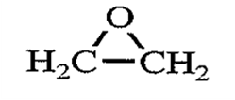

Sayfa | Başlık | Paragraf |  |  | Tanımlama | Kimyasal Yapı
 | 29.11 |  |  |  | Acetals and hemiacetals, whether or not with other oxygen function,and tehir halogenated, sulphonated, nitrated or nitrosated derivatives
VI-2911-1 |  | (A) |  |  | ACETALS AND HEMIACETALS | 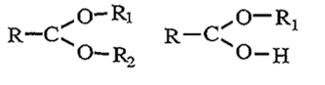
 | 29.12 |  |  |  | Aldehydes,whether or not with other oxygen function;cyclic polymers of aldehydes; paraformaldehyde
VI-2912-2 |  | (A) |  |  | Aldehydes | 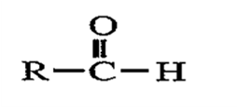
VI-2912-3 |  |  | (IV) | (1) | Benzaldehyde | 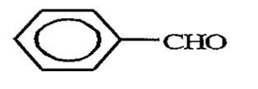
 |  | ( C) |  |  | ALDEHYDE-ETHERS,ALDEHYDE-PHENOLS AND ALDEHYDES WITH OTHER OXYGEN FUNCTION

Ek – Fasıl 29
Sayfa |  | Başlık |  | Paragraf |  |  |  |  |  | Tanımlama |  | Kimyassal Yapı
(V1--2912-3) |  | (29.12) |  | ( C ) |  |  | (1) |  |  | Vanilin |  | 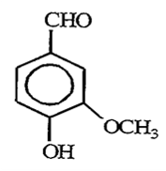
 |  |  |  | (D) |  |  |  |  |  | CYCLIC POLYMERS OF ALDEHYDES
VI-2912-4 |  |  |  |  |  |  | (1) |  |  | Trioxan |  | 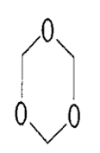
 |  | 29.14 |  |  |  |  |  |  |  | Ketones and quinones,whether or not with other oxygen function,and their halogenated, sulphonated, nitrated or nitrosated derivatives
V1-2914-2 |  |  |  | (A) |  |  |  |  |  | Ketones |  | 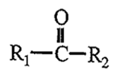
 |  |  |  |  |  |  | (II) |  | (I) | Camphor |  | 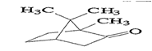
Sayfa | Başlık |  | Paragraf |  |  |  |  | Tanımlama |  |  | Kimyasal Yapı
 | (29.14) |  | ( E) |  |  |  |  | QUINONES
VI-2914-4 |  |  |  |  | (1) |  |  | Anthraquinone |  |  | 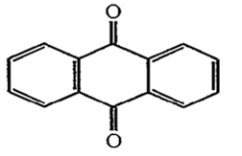
 |  |  | (F) |  |  |  |  | Quınone-Alcohols, Quınone-Phenols,
 |  |  |  |  |  |  |  | Quınone-Aldehydes And Other Oxygen Functıon Quınones
VI-2914-5 |  |  |  |  | (4) |  |  | Koenzim Q10  (ubidecarenone (INN) |  |  | 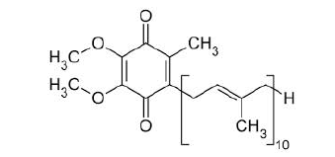
 | 29.15 |  |  |  |  |  |  | Saturated acyclic monocarboxylic acids and their anhydrides,halides, peroxides and peroxyacids; their halogenated, sulphonated,nitrated or nitrosated derivatives
VI-2915-5 |  |  | (V) |  | (a) |  |  | n-Butyric acid |  |  | 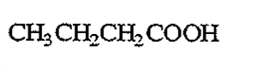
 | 29.16 |  |  |  |  |  |  | Unsaturated acyclic monocarboxylic acids,cyclic monocarboxylic acids,their anhydrides,halides,peroxides andperoxyacids;their halogenated,sulphonated, nitrated or nitrosated derivatives
 |  |  | (A) |  |  |  |  | Unsaturated acyclic monocarboxylic acids,and tehir salts,esters and other derivatives
VI-2916-1 |  |  |  |  | (1) |  |  | Acrylic acid |  |  | 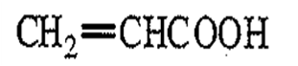

Ek – Fasıl 29

Sayfa | Başlık | Paragraf |  |  | Tanımlama | Kimyasal Yapı
 | (29.16) | (C) |  |  | AROMATİC SATURATED MONACARBOXYLIC ACIDS AND THEIR SALTS, ESTERS AND OTHER DERIVATIVES
VI-2916-2 |  |  | (1) |  | Benzoic acid | 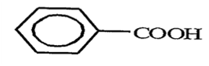
 |  |  |  | (a) | Benzoyl peroxide | 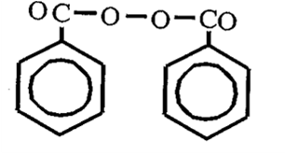  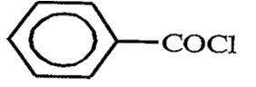
 |  | (C) | (1) | (b) | Benzoyl chloride
 | 29.17 |  |  |  | Polycarboxyylic acids, their anhydrides, halides, peroxides and peroxyacids, their halogenated, sulphonated, nitrated or nitrosated derivatives
 |  | (A) |  |  | ACYCLIC POLYCARBOXYLIC ACIDS AND THEIR ESTERS,SALTS AND DERIVATIVES
Ek – Fasıl 29

Sayfa | Başlık | Paragraf |  |  | Tanımlama | Kimyasal Yapı
VI-2917-1 | (29.17) |  | (3) |  | Azelaic acid | 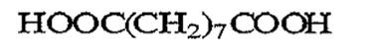
VI-2917-2 |  | (A) | (5) |  | Maleic anhydride | 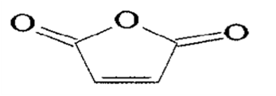
 |  | ( C) |  |  | AROMATIC POLYCBAOXYLIC ACIDS AND THEIR ESTERS, SALTS AND OTHER DERIVATIVES
 |  |  | (1) |  | Phthalic anhydride | 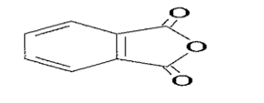
 |  |  | (2) |  | Terephthalic acid | 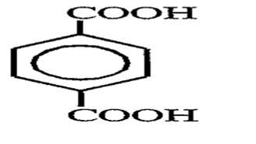

Ek – Fasıl 29

Sayfa | Başlık | Paragraf |  |  | Tanımlama | Kimyasal Yapı
 | 29.18 |  |  |  | Carboxylic acids with additional oxygen function and their anhydrides, halides, peroxides and peroxyacids; their halogenated, sulphonated, nitrated or nitrasated derivatives
 |  | (A) |  |  | CARBOXYLIC ACIDS WITH ALCOHOL FUNCTION AND THEIR ESTERS, SALTS AND OTHER DERIVATIVES
VI-2918-2 |  |  | (3) |  | citric acid | 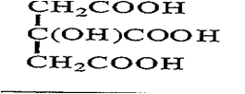
V1-2918-3 |  |  | (6) |  | Phenylglycolic acid | 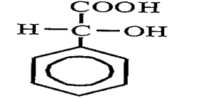
 |  |  | (8) |  | 2,2-Difenil-2-  hidroksiasetik asit  (benzilik asit) | 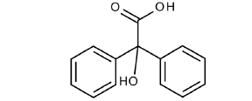
 |  | (B) |  |  | CARBOXYLIC ACIDS WITH PHENOL FUNCTION AND THEIR ESTERS,SALTS AND OTHER DERIVATIVES

Ek – Fasıl 29

Sayfa | Başlık | Paragraf |  |  | Tanımlama | Kimyasal Yapı
(VI-2918-3) | (29.18) | (B) | (I) |  | Salicylic acid | 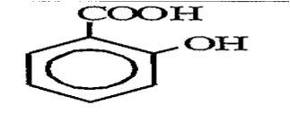
VI-2919-1 | 29.19 |  |  |  | phosphoric esters and their salts,inculuding lactophosphates;their halogenated,sulphonated,nitrated or nitrosated derivatives | 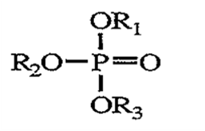
VI-2919-2 |  | (3) |  |  | Tributyl phosphate | 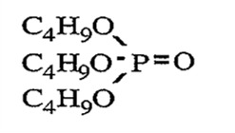
 | 29.20 |  |  |  | Esters of other inorganic acids of non-metals(excluding esters of hydrogen halides) and their salts; their halogenated,sulphonated,nitrated or nitrosated derivatives
 |  | (A) |  |  | Thiophosphoric esters
VI-2920-1 |  |  |  |  | Sodium O,O-dibutyldithiophosphates | 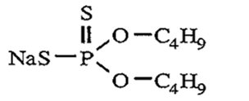
 |  | (B) |  |  | PHOSPHITE ESTERS AND THEIR SALTS.
 |  |  |  |  | Dimetil fosfit | 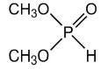
 |  | (C) |  |  | Nitrous and nitric esters
Ek – Fasıl 29
Sayfa | Başlık | Paragraf |  |  | Tanımlama | Kimyasal Yapı
(VI-2920-1) | (29.20) | (D) |  |  | Metthyl nitritie | 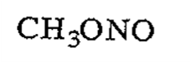
 |  |  |  |  | Nitroglycerol | 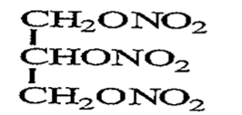
 |  | (E) |  |  | Carbonıic or peroxocarbonic esters and their salts
VI-2920-2 |  |  | (1) |  | Diguaiacyl carbonate | 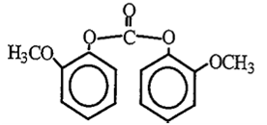
 |  | (F) |  |  | Silicic acid esters and their salts
 |  |  |  |  | Tetraethyl silicate | 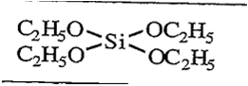
VI-2921-1 | 29.21 |  |  |  | Amine-function compounds | 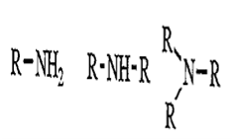
 |  | (A) |  |  | ACYCLIC MONOAMINES AND THEIR DERIVATIVES; SALTS THERE OF
VI-2921-2 |  |  | (4) |  | Ethylamine | 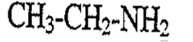

Ek – Fasıl 29

Sayfa | Başlık | Paragraf |  |  | Tanımlama | Kimyasal Yapı
 | (29.21) | (B) |  |  | ACYCLIC POLYAMINES AND THEIR DERIVATIVES; SALTS THEREOF
VI-2921-3 |  |  | (2) |  | Hexamethylenediamine | 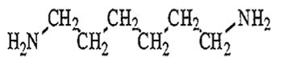
 |  | (D) |  |  | AROMATIC MONOAMINES AND THEIR DERIVATIVES; SALTS THEREOF
 |  |  | (1) |  | Aniline | 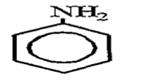
 |  |  | (2) |  | Toluidine(s) | 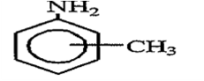
 |  |  | (4) |  | 1-Naphtylamine | 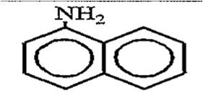
 |  | ( E) |  |  | AROMATIC POLYAMINES AND THEIR DERIVATIVES; SALTS THEREOF

Ek – Fasıl 29

Sayfa | Başlık | Paragraf |  |  | Tanımlama | Kimyasal Yapı
VI-2921-4 | (29.21) | (E) | (1) |  | Phenylenediamine(s) | 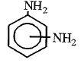
 | 29.22 |  |  |  | Oxygen-function amino-compounds
 |  | (A) |  |  | AMINO-ALCOHOLS, THEIR ETHERS AND ESTERS; SALTS THEREOF
VI-2922-2 |  |  | (1) |  | Monoethanolamine
 |  | (B) |  |  | AMINO-NAPHTHOLS AND OTHER AMINO-PHENOLS, THEIR ETHERS AND ESTERS; SALTS THEREOF
 |  |  | (1) |  | Aminohydroxynaphtalenesulphonic acids | 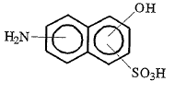

Ek – Fasıl 29

Sayfa | Başlık | Paragraf |  |  | Tanımlama | Kimyasal Yapı
VI-2922-3 | (29.22) | (B) | (a) |  | Anisidine(s) | 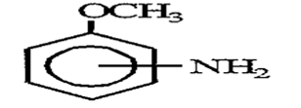
 |  |  | (b) |  | Dianisidine(s) | 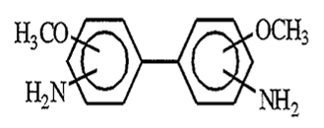
 |  | (D) |  |  | AMINO-ACIDS AND THEİR ESTERS; SALTS THEREOF
 |  |  | (1) |  | Lysine | 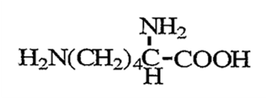
 | 29.23 |  |  |  | Quaternary ammonium salts and hydroxides; lecithins and other phosphoaminolipids, whether or not chemically defined
VI-2923-1 |  | (1) |  |  | Choline (choline hydroxide) | 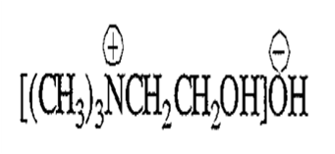

Ek – Fasıl 29
Sayfa | Başlık | Paragraf |  |  | Tanımlama | Kimyasal Yapı
(VI-2923-1) | (29.23) | (2) |  |  | Lecithin | 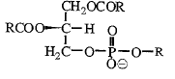
 | 29.24 |  |  |  | Carboxyamide-function compounds; amide-function compounds of carbonic acid
 |  | (B) |  |  | CYCLIC AMIDES
VI-2924-2 |  |  | (1) | (ii) | Diethyldiphenylurea | 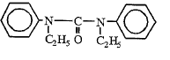
 | 29.25 |  |  |  | Carboxyamide-function compounds (including saccharin and its salts) and imine-function compounds
 |  | (A) |  |  | IMIDES
VI-2925-1 |  |  | (1) |  | Saccharin | 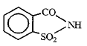
 |  | (B) |  |  | IMINES

Ek – Fasıl 29
Sayfa | Başlık | Paragraf |  |  | Tanımlama | Kimyasal Yapı
VI-2925-2 | (29.25) | (B) | (1) | (a) | Diphenylguanidine | 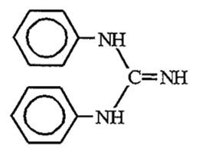
 |  |  | (3) |  | Imino ethers | 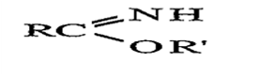
 | 29.26 |  |  |  | Nitrile-function compound
VI-2926-1 |  | (1) |  |  | Acrylonitrile | 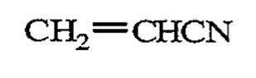
 |  | (2) |  |  | 1-Cyanoguanidine | 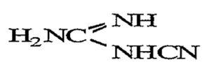
 |  | (19) |  |  | alfa-Fenilasetoasetonitril  (APAAN) | 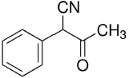
 | 29.27 |  |  |  | Diazo-,azo- or azoxy-compounds
 |  | (A) |  |  | DIAZO-COMPOUNDS

Ek – Fasıl 29

Sayfa | Başlık | Paragraf |  |  | Tanımlama | Kimyasal Yapı
VI-2927-1 | (29.27) | (A) | (1) | (a) | Benzenediazonium chloride | 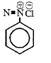
 |  | (B) |  |  | AZO-COMPOUNDS
 |  | (C) |  |  | AZOXY-COMPOUNDS
VI-2927-2 |  |  | (1) |  | Azoxybenzene | 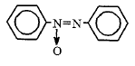
 | 29.28 |  |  |  | Organic derivatives of hydrazine or of hydroxylamine
VI-2928-1 |  | (1) |  |  | Phenylhydrazine | 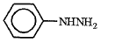
 |  | (11) |  |  | Phenylgyoxime | 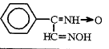

Ek – Fasıl 29

Sayfa | Başlık | Paragraf |  |  | Tanımlama | Kimyasal Yapı
 | 29.29 |  |  |  | Compounds with other nitrogen function
VI-2929-1 |  | (1) |  |  | Isocyanates | 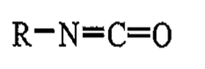
 | S-Ch.X General |  |  |  | ORGANO-INORGANIC COMPOUNDS, HETEROCYCLIC COMPOUNDS, NUCLEIC ACIDS AND THEIR SALTS AND SULPHONAMIDES
 |  | (A) |  |  | FIVE-MEMBERED RINGS
VI-2930-1 |  |  | (1) | (a) | Furan | 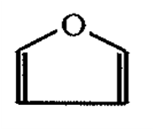
 |  |  |  | (b) | Thiophen | 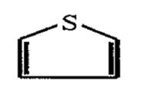
 |  |  |  | ( c) | Pyrrole | 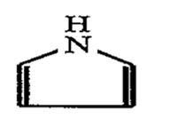
 |  |  | (2) | (a) | Oxazole | 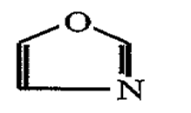
Sayfa | Başlık | Paragraf |  |  | Tanımlama | Kimyasal Yapı
(VI-2930-1) | (General) | (A) | (2) | (a) | Isaxazole | 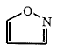
 |  |  |  | (b) | Thiazole | 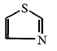
 |  |  |  | (c) | Imidazole | 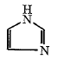
 |  |  |  | (c) | Pyrazole | 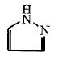
 |  |  | (3) | (a) | Furazan | 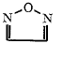

Ek – Fasıl 29

Sayfa | Başlık | Paragraf |  |  | Tanımlama | Kimyasal Yapı
(VI-2930-1) | (General) | (A) | (3) | (b) | Triazole (1,2,4-Triazole) | 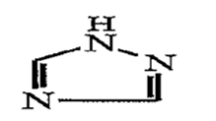
 |  |  |  | ( c) | Tetrazole | 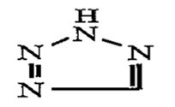
 |  | (B) |  |  | SIX-MEMBERED RINGS
VI-2930-2 |  |  | (1) | (a) | Pyran (2H-Pyran) | 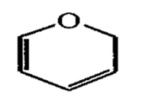
 |  |  |  | (b) | Thiin | 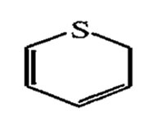
 |  |  |  | ( c) | Pyridine | 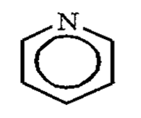
Ek – Fasıl 29

Sayfa | Başlık | Paragraf |  |  | Tanımlama | Kimyasal Yapı
(VI-2930-2) | (General) | (B) | (2) | (a) | Oxazine  (1,4-Oxazine) | 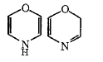
 |  |  |  | (b) | Thiazine  (1,4- Thiazine) | 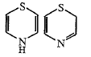
 |  |  |  | (c) | Pyridazine | 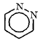
 |  |  | (1) | (c) | Pyrimidine | 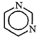
 |  |  |  | (c) | Pyrazine | 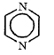

Ek – Fasıl 29

Sayfa | Başlık | Paragraf |  |  | Tanımlama | Kimyasal Yapı
(VI-2930-2) | (General) | (B) | (2) | ( c) | Piperazine | 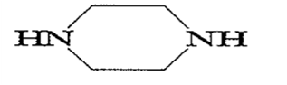
 |  | ( C) |  |  | OTHER MORE COMPLEX HETEROCYCLIC COMPOUNDS
 |  |  | (a) |  | Coumarone | 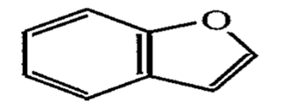
 |  |  | (b) |  | Benzopyran | 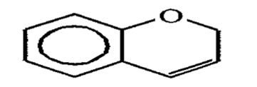
 |  |  | (c) |  | Xanthene | 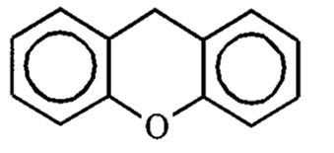
 |  |  | (d) |  | Indole | 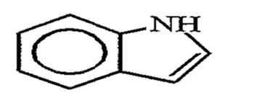

Ek – Fasıl 29

Sayfa | Başlık | Paragraf |  |  | Tanımlama | Kimyasal Yapı
(VI-2930-2) | (General) | (C) | (e) |  | Quinoline and isoqıinoline | 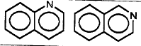
 |  |  | (f) |  | Acridine | 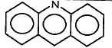
 |  |  | (g) |  | Benzothiophene (Thionaphthene) | 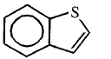
 |  |  | (h) |  | Indazole | 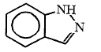
 |  |  | (ij) |  | Benzimidazole | 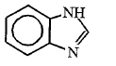
Ek – Fasıl 29

Sayfa | Başlık | Paragraf |  |  | Tanımlama | Kimyasal Yapı
(VI-2930-2) | (General) | (C) | (k) |  | Phenazine | 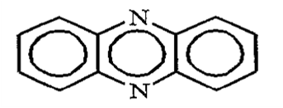
 |  |  | (1) |  | Phenoxazine | 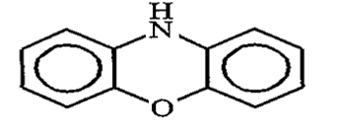
 |  |  | (m) |  | Benzoxazole | 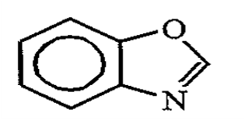
 |  |  | (n) |  | Carbazole | 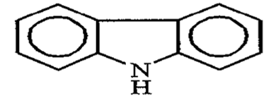
 |  |  | (o) |  | Quinazoline | 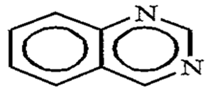
Ek – Fasıl 29

Sayfa | Başlık | Paragraf |  |  | Tanımlama | Kimyasal Yapı
(VI-2930-2) | (General) | (C) | (p) |  | Benzothiazole | 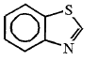
 | 29.30 |  |  |  | Organo-Sulphur compounds | Compounds with C-S bond
VI-2930-3 |  | (A) |  |  | DITHIOCARBONATES (XANTHATES)
 |  |  | (1) |  | Sodium ethyldihiocarbonate | 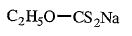
 |  | (B) |  |  | THIOCARBAMATES DITHIOCARBAMATES AND THIURAM SULPHIDES
 |  |  | (2) |  | Dithiocarbamates | 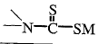
VI-2930-4 |  | (C) |  |  | SULPHIDES (OR THIOETHERS) | R.S.R₁
 |  |  | (1) |  | Methionine | 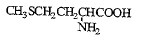
 |  | (D) |  |  | THIOAMIDES | 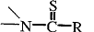
Ek – Fasıl 29

Sayfa | Başlık | Paragraf |  |  | Tanımlama | Kimyasal Yapı
(VI-2930-4) | (29.30) | (D) | (2) |  | Thiocarbanilide | 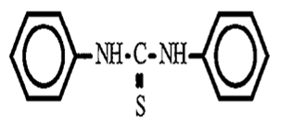
 | 29.31 |  |  |  | Other organo-inoprganic compounds
VI-2931-1 |  | (2) |  |  | Organo-silicon compounds | Compounds with C-Si bond
 |  |  |  |  | Hexamethyldisiloxane | 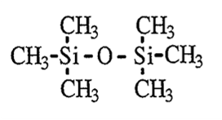
 |  | (3) |  |  | Dimetil metilfosfonat | 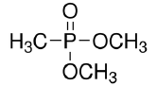
 | 29.32 |  |  |  | Heterocyclic compounds with oxygen hetero-atom(s) only
VI-2932-1 |  | (A) |  |  | Compounds containing an unfused furan ring (whether or not hydrogenated) in the structure | (See structure of furan against page VI-2930-1 for Sub-Chapter X (A) (1) (a) )
 |  |  | (2) |  | 2-Furaldehyde | 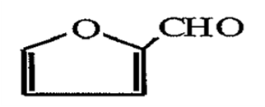
 |  |  | (3) |  | Furfuyl alcohol | 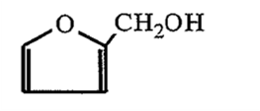
 |  |  | (5) |  | Sukraloz | 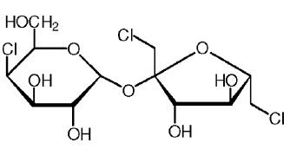

Ek – Fasıl 29

Sayfa | Başlık | Paragraf |  |  | Tanımlama | Kimyasal Yapı
VI-2932-2 | (29.32) | (B) |  |  | Lactones | 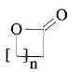
 |  |  | (a) |  | Coumarin | 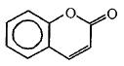
VI-2932-3 |  |  | (p) |  | Phenolphthalein | 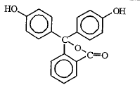
 |  | (C) |  |  | Other heterocyclic compounds with oxygen hetero-atom(s) only
 |  |  | (5) |  | Safrole | 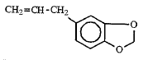
Ek – Fasıl 29

Sayfa | Başlık | Paragraf |  |  | Tanımlama | Kimyasal Yapı
VI-2932-4 | (29.32) | ( C) | (10) |  | 1-(1,3-Benzodioxol-5-yl) propan-2-one | 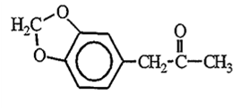
 |  |  |  |  | Example for esters (lactone) forming part of two rings (Subheading Explanatory Notes) | 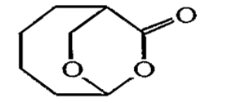
 |  |  |  |  | Example for dilactone (Subheading Explanatory Notes) | 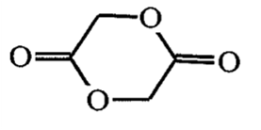
 |  |  |  |  | Internal Hemiacetals | 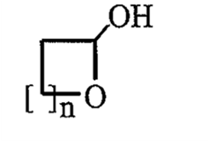

Sayfa | Başlık | Paragraf |  |  | Tanımlama | Kimyasal Yapı
(VI-2932-4) | (29.32) |  |  |  | Ketone peroxides (exclusion) –see 29.09 | 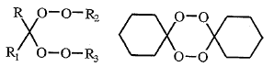
 | 29.33 |  |  |  | Heterocyclic compounds with nitrogen heteroatom(s) only
VI-2933-2 |  | (A) |  |  | Compounds containing an unfused pyrazole ring (whether or not hydrogenated) in the structure | (See structures of pyrazole against page VI-2930-1 for Sub-Chapter X (A) (2) (c))
 |  |  | (1) |  | Phenazone | 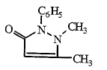
 |  | (B) |  |  | Compounds containing an unfused imidazole ring (whether or not hydrogenated) in the structure | (See structures of imidazole against page VI-2930-1 for Sub-Chapter X (A) (2) (c))
 |  |  | (1) |  | Hydantoin | 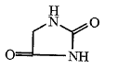
VI-2933-3 |  | (C) |  |  | Compounds containing an unfused pyridine ring (whether or not hydrogenated) in the structure | (See structures of pyridine against page VI-2930-2 for Sub-Chapter X (B) (1) (c))
 |  |  |  |  | Fentanyl (INN)

Ek – Fasıl 29

Sayfa | Başlık | Paragraf |  |  | Tanımlama | Kimyasal Yapı
VI-2933-4 | (29.33) | (D) |  |  | Compounds containing a quinoline or isoquiniline ring-system (whether or not hydrogenated) not further fused | (See structures of quinoline and isoquinoline against page VI-2930-2 for Sub-Chapter X( C) ( e))
 |  |  | (4) |  | Tetrahdydromethylquinoline (5,6,7,8-Tetrahydromethylquinoline) | 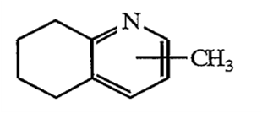
 |  | ( E) |  |  | Compounds containing a pyrimidine ring(whether or not hydrogenated) or piperazine ring in the structure | (See structure of pyrimidine against page VI-2930-2 for Sub-Chapter X( B) (2)( c))
 |  |  | (1) |  | Malonylurea ( Barbituric acid) | 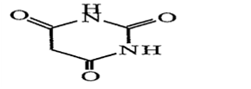
VI-2933-5 |  | (F) |  |  | Compounds containing an unfused triazine ring (whether or not hydrogenated) in the structure | 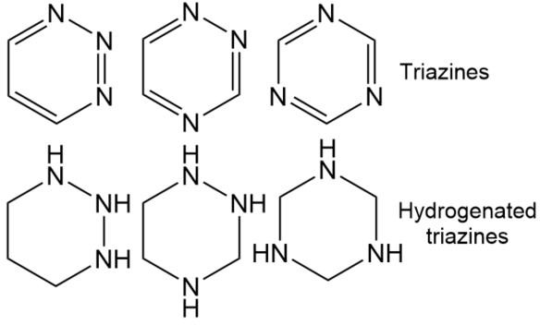

Ek – Fasıl 29

Sayfa | Başlık | Paragraf |  |  | Tanımlama | Kimyasal Yapı
(VI-2933-5) | (29.33) | (F) | (1) |  | Melamine | 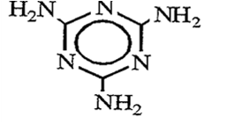
 |  | (G) |  |  | Lactams | 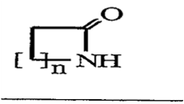
 |  | (H) |  |  | Other heterocyclic compounds with nitrogen hetero-atom(s) only
VI-2933-6 |  |  | (1) |  | Carbazole | 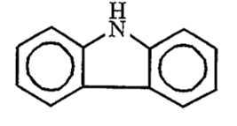
 |  |  | (2) |  | Acridine | See structure of acridine against page VI-2930-2 for Sub-Chapter X( C ) (f))

Ek – Fasıl 29

Sayfa | Başlık | Paragraf |  |  | Tanımlama | Kimyasal Yapı
VI-2933-7 | (29.33) |  |  |  | Oxazepam (Subheading Explanatory Notes) | 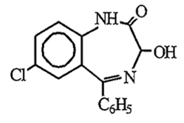
 |  |  |  |  | Example for amide (lactam) forming part of two rings (Subheading Explanatory Notes) | 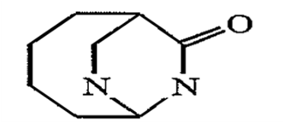
 | 29.34 |  |  |  | Nucleic acids and their salts, whether or not chemically defines; other heterocyclic compounds
VI-2934-1 |  | (A) |  |  | Compounds containing an unfused thiazole ring ( whether or not hydrogenated) in the structure | See structure of thiazole against page VI-2930-1 for Sub-Chapter X (A) (2)(b))
 |  | (B) |  |  | Compounds containing a benzothiazole ring-system (whether or not hydrogenated),not further fused | (See structure of benzothiazole against page VI-2930-2 for Sub-Chapter X (C )(p))
VI-3934-2 |  | ( C) |  |  | Compounds containing a phenothiazine ring-system(whether or not hydrogenated)not further fused | 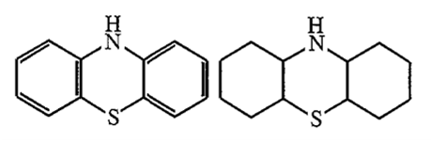
 |  | (D) |  |  | Other heterocyclic compounds
Ek – Fasıl 29

Sayfa | Başlık | Paragraf |  |  | Tanımlama | Kimyasal Yapı
(VI-2934-2) | (29.34) | (D) | (1) |  | Sultones | 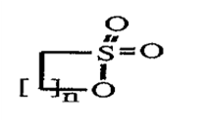
 |  |  |  | (a) | Phenolsulfonephthalein | 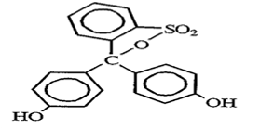
 |  |  | (2) |  | Sultams | 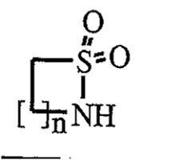
 |  |  | (4) |  | Furazolidone (INN) | 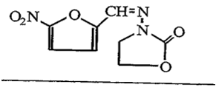

Ek – Fasıl 29

Sayfa |  | Başlık | Paragraf |  |  |  |  |  |  | Tanımlama |  | Kimyasal Yapı
VI-2935-1 |  | 23.35 |  |  |  |  |  |  |  | Sulphonamides |  | 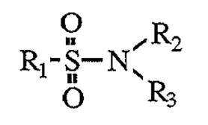
 |  |  | (1) |  |  |  |  |  |  | Perfluorooktan  sülfonamid |  | 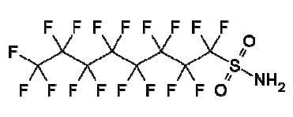
 |  |  | (5) |  |  |  |  |  |  | p-Aminobenzenesulphonamide |  | 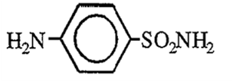
 |  | 29.37 |  |  |  |  |  |  |  | Hormones, prostaglandins, thromboxanes and leukotrienes, natural or reproduced by synthesis; derivatives and structural analogues thereof,including chain modified polypeptides,used primarily as hormones
 |  |  | (V) |  |  |  |  |  |  | Anologues of hormones, prostaglandins, thromboxanes and leukotrienes
VI-2937-2 |  |  |  |  |  | (b) |  |  |  | Gonane |  | 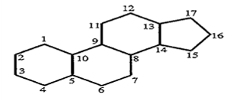
Sayfa | Başlık |  |  | Paragraf |  |  |  |  | Tanımlama |  | Kimyasal Yapı
 | (29.37) |  |  | (B) |  |  |  |  | STEROIDAL HORMONES, THEIR DERIVATIVES AND STRUCTURAL ANALOGUES
 |  |  |  |  | (1) |  |  |  | Corticosteroid hormones
VI-2937-5 |  |  |  |  |  |  | (a) |  | Cortisone (INN) |  | 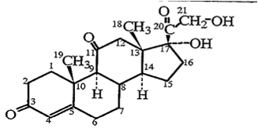
 |  |  |  |  |  |  | (b) |  | Hydrocortisone (INN) |  | 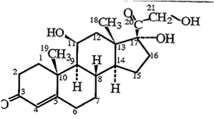
VI-2937-6 |  |  |  |  | (3) |  |  |  | Oestrogens and progestogens

Sayfa | Başlık | Paragraf |  |  | Tanımlama | Kimyasal Yapı
(VI-2937-6) | (29.37) | (B) | (3) | (a) | Progesterone (INN) | 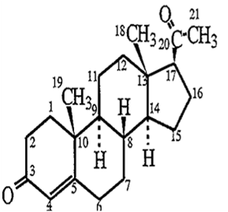
VI-2937-8 |  | List |  |  | Androstane | 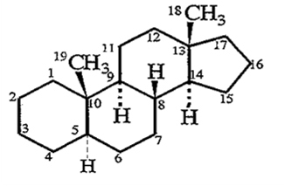
VI-2937-10 |  |  |  |  | Estrone (INN) | 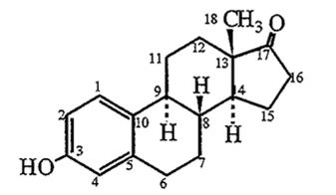

Ek – Fasıl 29

Sayfa | Başlık | Paragraf |  |  | Tanımlama | Kimyasal Yapı
VI-2937-13 | (29.37) | List |  |  | Prednisolone (INN) | 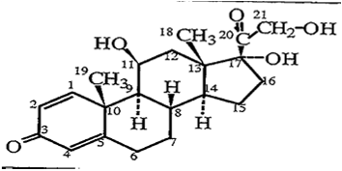
 |  |  |  |  | Prednisone (ınn) | 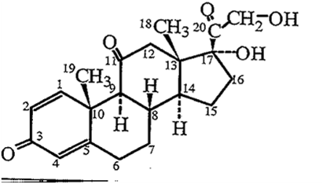
VI-2937-14 |  |  |  |  | Testosterone (INN) | 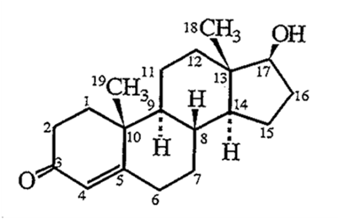

Ek – Fasıl 29

Sayfa | Başlık | Paragraf |  |  | Tanımlama | Kimyasal Yapı
- | (29.37) |  |  |  | Estrane | 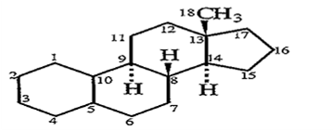
- |  |  |  |  | Pregnane | 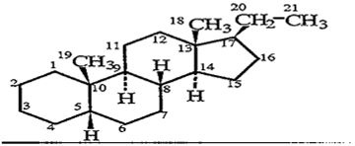
 | 29.38 |  |  |  | Glycosides,natural or reproduced by synthesis,and their salts,ethers esters and other derivatives
VI-2938-1 |  | (1) |  |  | Rutoside | 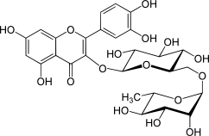
 | 29.39 |  |  |  | Alkaloids, natural or reproduced by synthesis,and their salts,ethers esters and other derivatives

Ek – Fasıl 29

Sayfa | Başlık | Paragraf |  |  | Tanımlama | Kimyasal Yapı
 | (29.39) | (A) |  |  | ALKALOIDS OF OPIUM AND THEIR DERIVATIVES; SALTS THEREOF
VI-2939-2 |  |  | (1) |  | Morphine | 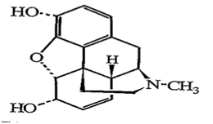
 |  | (B) |  |  | ALKALOIDS OF CINCHONA AND THEIR DERIVATIVES; SALTS THEREOF
VI-2939-3 |  |  | (1) |  | Quinine | 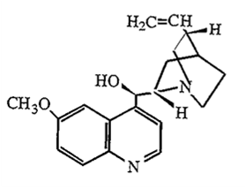
 |  | ( C) |  |  | CAFFEINE AND ITS SALTS

Ek – Fasıl 29

Sayfa | Başlık | Paragraf |  |  | Tanımlama | Kimyasal Yapı
(VI-2939-3) | (29.39) | ( C) |  |  | Caffeine | 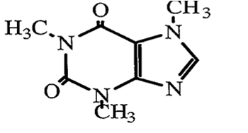
 | (29.39) | (D) |  |  | ALKALOIDS OF EPHEDRA AND THEIR DERIVATIVES;  SALTS THEREOF
  (VI-2939-3)
 |  |  | (1) |  | Ephedrine | 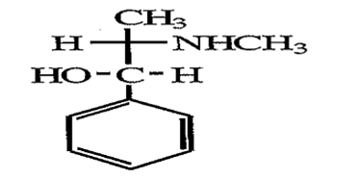
 |  | ( E) |  |  | THEOPHYLLINE AND AMINOPHYLLINE ( THEOPHYLLINE- ETHYLENEDIAMINE) AND THEIR DERIVATIVES; SALTS THEREOF

Ek – Fasıl 29

Sayfa | Başlık | Paragraf |  |  | Tanımlama | Kimyassal Yapı
(VI-2939-3) | (29.39) | ( E) |  |  | Theophylline | 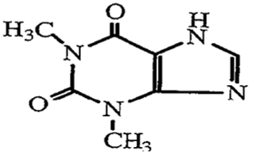
 |  | (G) |  |  | NICOTINE AND ITS SALTS
VI-2939-4 |  |  |  |  | Nicotine | 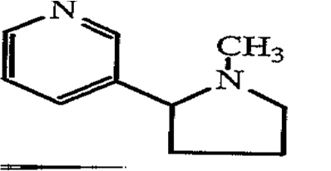
VI-2939-6 |  |  |  |  | Bitkisel kökenli olmayan alkaloitler
 |  | (IJ) |  |  | viridicatin (mantar),  histrinocotoxin (hayvansal),  coccinelline (böcek),  varacin (denizel) ve  procyanine (bakteriyel) | 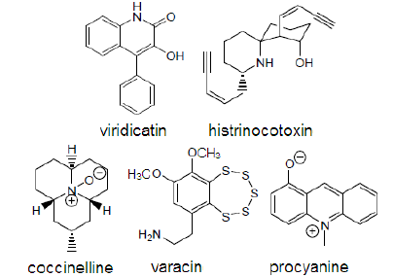
 | 29.40 |  |  |  | Sugars, chemically pure, other than sucrose, lactose, maltose, glucose and fructose; sugar ethers, sugar acetals and sugar esters, and their salts, otjher than products of heading 29.37,29.38 or 29.39
 |  | ( A) |  |  | SUGARS, CHEMICALLY PURE
Sayfa | Başlık | Paragraf |  |  | Tanımlama | Kimyasal Yapı
VI-2940-1 | (29.40) | (A) | (1) |  | Galactose | 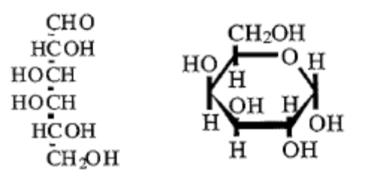
 |  | (B) |  |  | SUGAR ETHERS, SUGAR ACETALS AND SUGAR ESTERS, AND THEİR SALTS
VI-2940-2 |  |  | (1) |  | Hydroxypropyl sucrose | 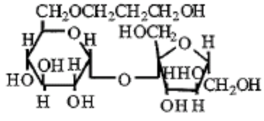
 | 29.41 |  |  |  | Antibiotics
VI-2941-1 |  | (1) |  |  | Penicillins | 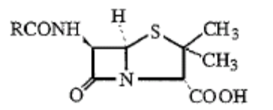

Sayfa | Başlık | Paragraf |  |  | Tanımlama | Kimyasal Yapı
 | (29.41) | (2) |  |  | Streptomycin | 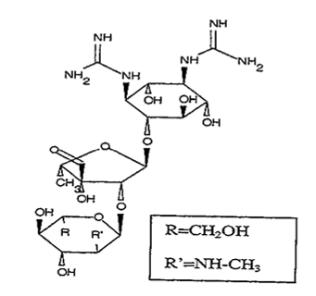
VI-2941-2 |  |  |  |  | Streptamine (constituent of the streptomycin skeleton) ( Subheading Explanatory Notes) | 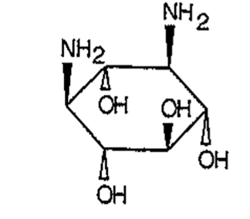

Ek – Fasıl 29

Sayfa | Başlık | Paragraf |  |  | Tanımlama | Kimyasal Yapı
VI-2941-2 | (29.41) |  |  |  | Streptidine (constituent of the streptomycin skeleton) (Subheading Explanatory Notes) | 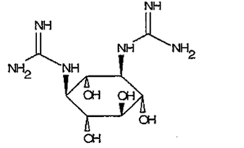
 |  |  |  |  | Methylglucosamine (constituent of the streptomycin skeleton) (Subheading Explanatory Notes) | 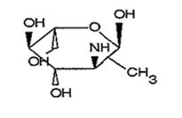
 |  |  |  |  | 5-deoxylyxose (constituent of the streptomycin skeleton) (Subheading Explanatory Notes) | 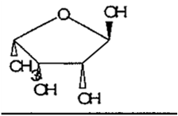
VI-2941-1 |  | (3) |  |  | Tetracycline | 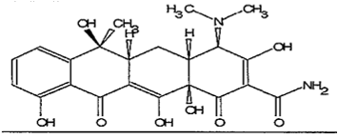

Ek – Fasıl 29

Sayfa | Başlık | Paragraf |  |  | Tanımlama | Kimyasal Yapı
VI-2941-3 |  |  |  |  | 4- dimethylamino- naphthacene- 2- carboxamide (constituent of the tetracycline skeleton) (Subheading Explanatory Notes) | 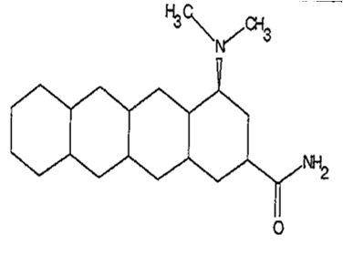
 |  |  |  |  | N-(2-hydroxy-1- methyl-2- phenethyl) acetamide (constituent of the chloramphenicol skeleton) ( Subheading Explanatory Notes) | 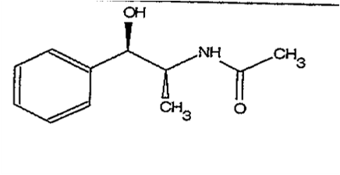

Ek – Fasıl 29

Sayfa | Başlık | Paragraf |  |  | Tanımlama | Kimyasal Yapı
VI-2941-1 | (29.41) | (5) |  |  | Erythromycin | 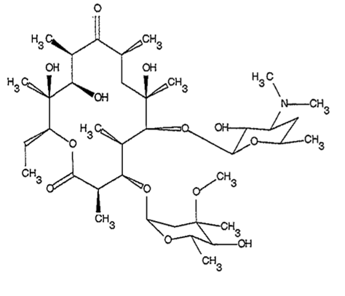
VI-2941-3 |  |  |  |  | 13-ethyl-13- tridecanolide (constituent of the erythromycin skeleton) (Subheading Explanatory Notes) | 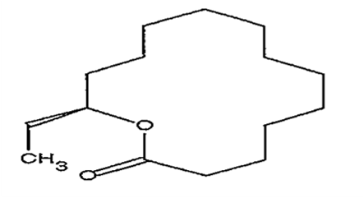

Ek – Fasıl 29

Sayfa | Başlık | Paragraf |  |  | Tanımlama | Kimyasal Yapı
(VI-2941-3) | (29.41) |  |  |  | Desosamine ( constituent of the erythromycin skeleton) ( Subheading Explanatory Notes) | 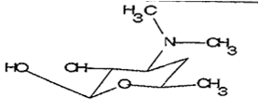
 |  |  |  |  | Mycarose( constituent of the erythromycin skeleton) (Subheading Explanatory Notes) | 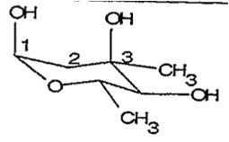
 | 29.42 |  |  |  | Other organic compounds
VI-2942-1 |  | (1) |  |  | Ketenes | 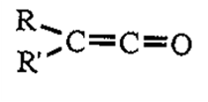
 |  | (2) |  |  | Boron trifluoride complexes with diethyl ether | 